
SINGLE/CROSS-CURRENCY SWAP GRID
(spots & forwards)
Developed in collaboration with GNI Financial Products
Actual trading screen :

tests
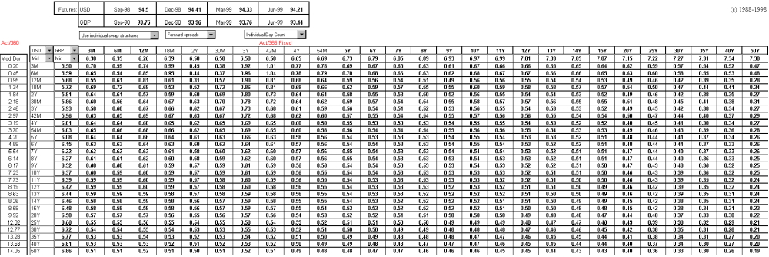
The above Swap Grid is one of many Excel based applications provided FREE with UNIVSWAP. Advantages over "closed " systems include:
- Ability to monitor arbitrage opportunities in real-time.
- New arbitrage ideas can be implemented in-house without divulging them to the "closed" system provider to implement for everyone else.
- Enhanced analytical capability. Ability to smoothly blend deposits, futures, FRAs, bills, swaps, bonds etc.
- Flexibility to easily customise the swap grid screen for each trading desk.
- Flexibility to link to most real-time feeds.
- Considerable cost saving. UNIVSWAP is provided as a one-off fee (£1,999 per machine), not a long term rental contract (see enclosed price list).

